Report

Date | 12 Dec 2025
Team ID | SWUID20250222796
Project Name | Predicting Plant Growth-Stages with Environmental and Management Data Using Power BI
Maximum Marks | 5 Marks

A report is a comprehensive document that provides a detailed and structured account of data analysis, findings, and insights. It is typically used for in-depth analysis, documentation, and communication of results. Reports are suitable for a diverse audience, including decision-makers, analysts, and stakeholders who need a comprehensive understanding of the data.
Designing a report in Power BI involves connecting to data sources, creating visualizations like charts and graphs, customizing their appearance and interactivity, organizing them logically on the canvas, formatting elements for consistency and clarity, and optionally creating dashboards for a summarized view. Throughout the process, it's essential to consider the audience's needs and ensure the report effectively communicates insights from the data. Finally, iterate based on feedback to continually improve the report's design and usefulness.

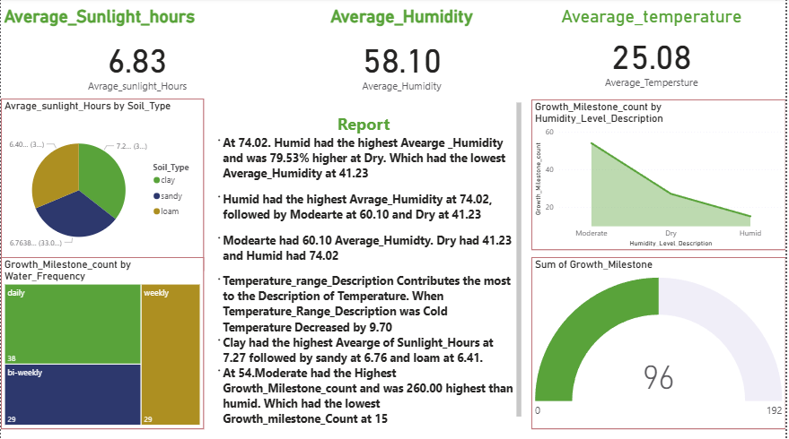

Final Dashboard Outcomes and Actionable Insights
The completed Power BI dashboard provides the following specific insights, achieving the project's objective of correlating factors with growth success.

A. Optimal Environmental Conditions
Humidity Segmentation: The Moderate humidity level achieved the highest Growth_milestone_count. This count was significantly 260.00 higher than the Humid level, demonstrating that intermediate humidity is optimal.

Fertilizer Performance: Chemical Fertilizer contributed the most to growth milestones (39.58% or 38 milestones), closely followed by Organic Fertilizer (36.75% or 36 milestones).

Soil and Light Efficiency: Clay soil is the most efficient at utilizing available light, recording the highest average sunlight hours at 7.27.

B. Actionable Management Insights
Optimal Watering: Weekly watering is the most resource-efficient optimal schedule, contributing 38 milestones, equal to the Daily schedule.

Temperature Influence: The Key Influencers visual demonstrated that when the Temperature_level_description is Cold, the average temperature decreases by 9.7. This provides a quantified target for climate control adjustments.

Highest Growth Combination (Detailed Analysis from Dashboard): The overall highest total growth count is achieved by the combination of Sandy soil with a weekly watering schedule (Total: 3,722.31).

